Spritet User Guide

Overview: This is a quick-start guide to using Spritet. Spritet is an application for creating and editing sprites and is able to run on Android, Linux, MacOSX, and Windows provided that ImageMagick is already installed.

Starting the Program
After launching Spritet, here is an example of the window which will be shown:
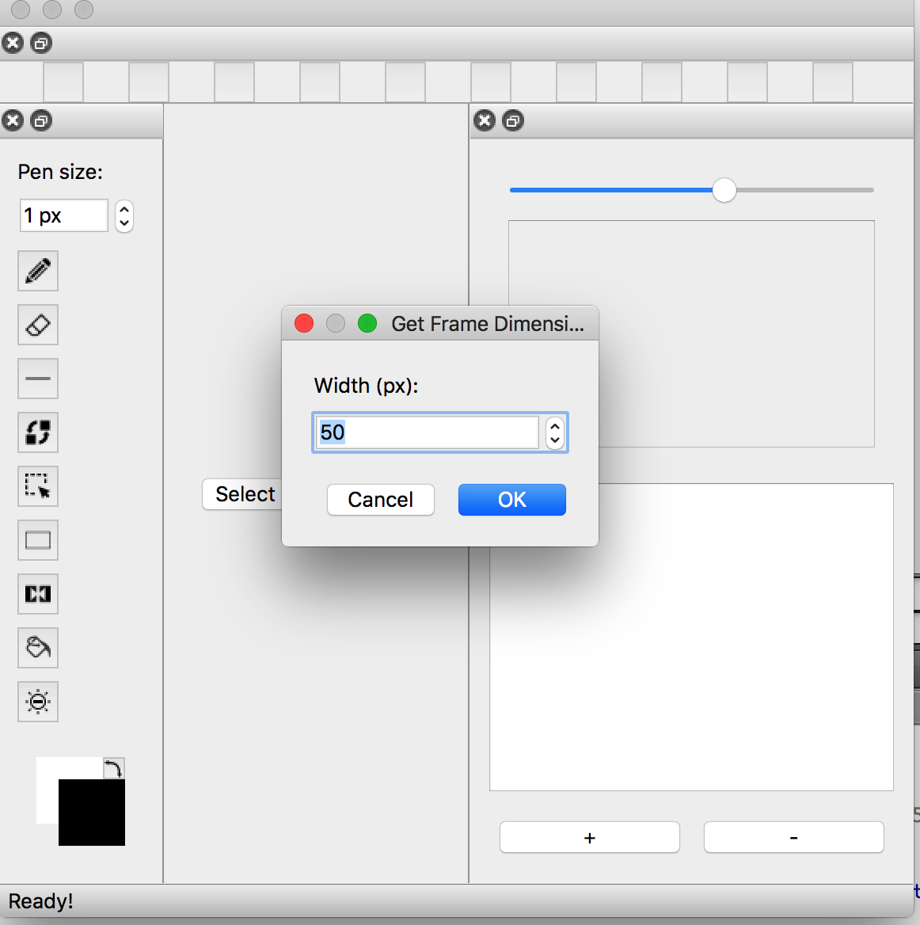
The user would be prompted to enter the width and height of frames that will be created in this session. If the user declines to do so, the default would be set to 50x50. Spritet is now ready to be used!
Main Canvas
The program starts with no frames. After clicking the plus button, a new frame will be added to the side. To view the frame in the center, click on the drop down box to display it. Press n to add panels to display in the center.
Frame List
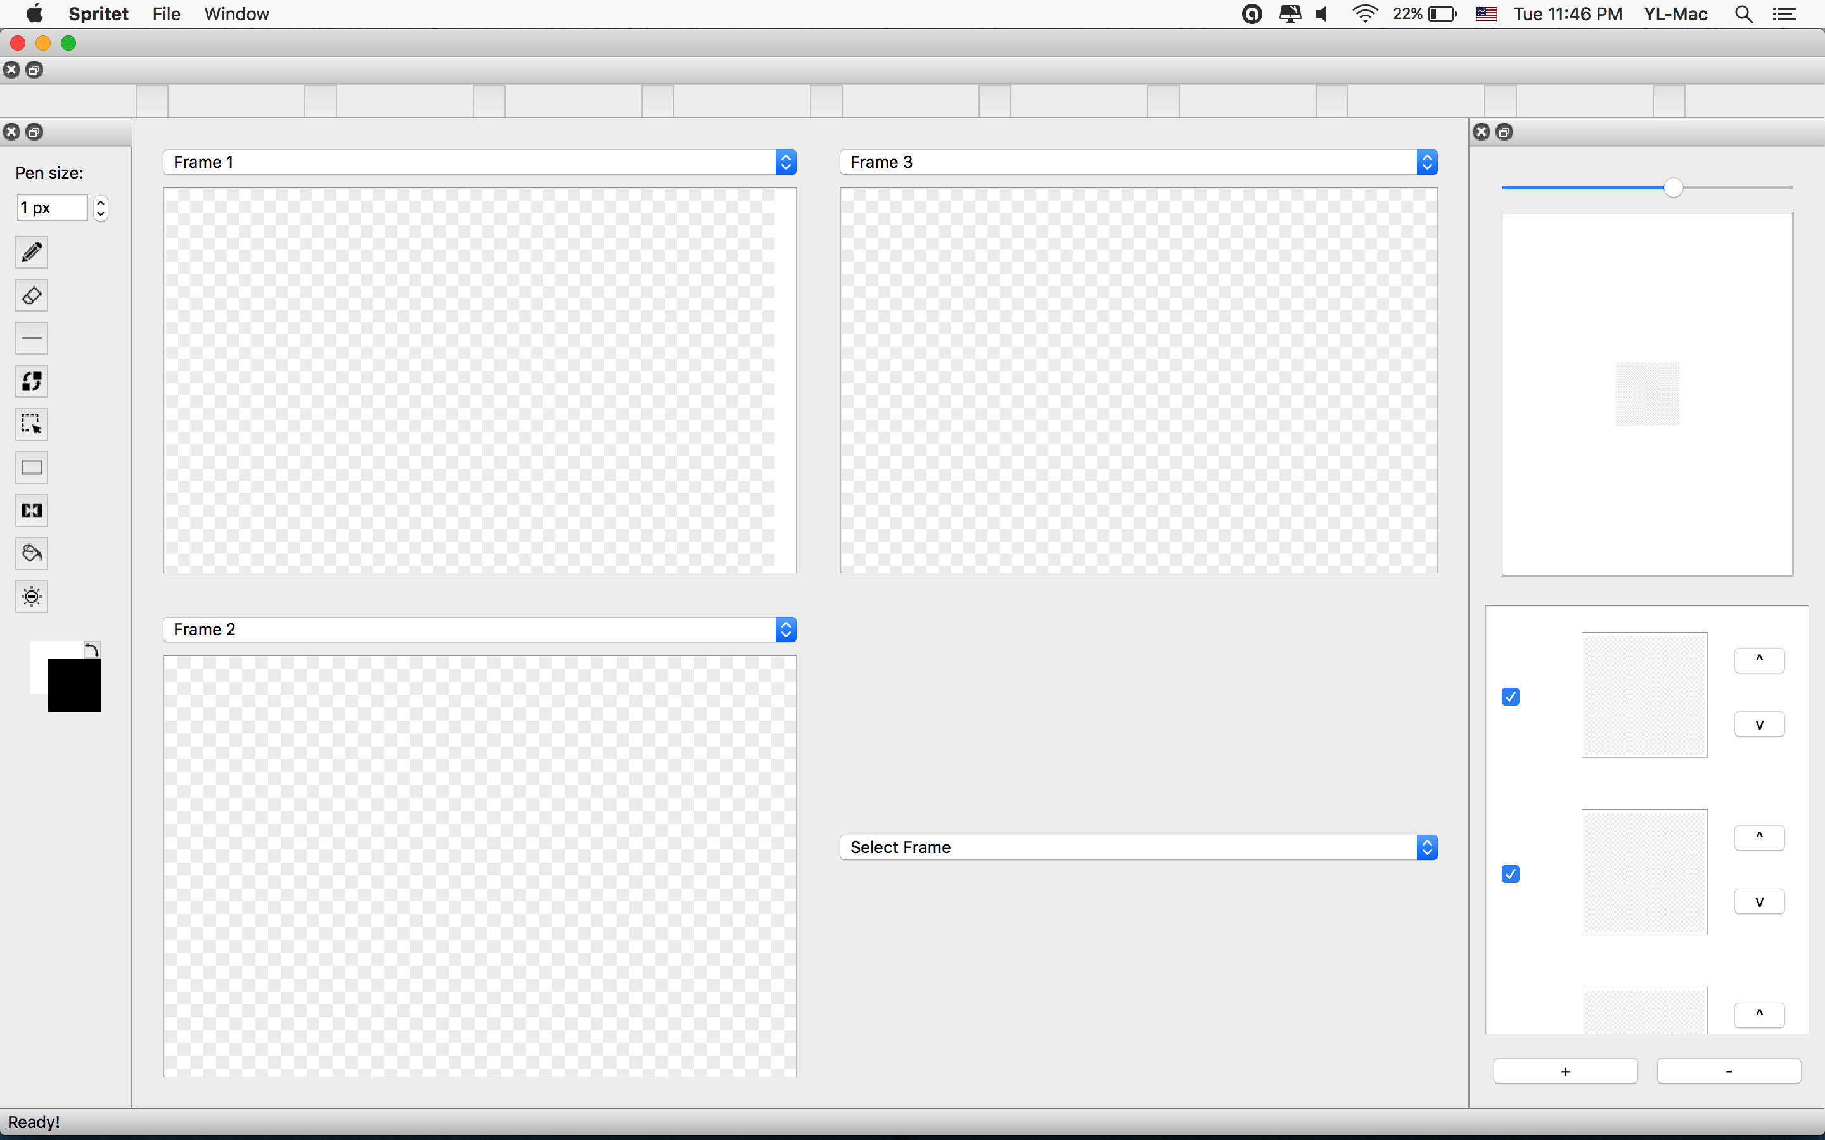
All frames in the project is displayed in a list of thumbnails in a window on the right. The user have the option of adding and deleting frames from the project using the + and – buttons at the button right window. If a panel is selected when the user press add, a new frame would be inserted directly after the highlighted frame. If there are no current frames or if no frames is selected, a new frame is added to the end. Users also have the option of changing the order the frames are displayed using the ^ and v buttons next to each thumbnail.

Preview
The animation formed by the frames are shown in a preview in the top right. Users have the option of adjusting the speed at which the animation change frames using a slider on the top of the preview. Users can also select which frames to show in the preview using a checkbox next to each frame’s thumbnail.

Tools
Spritet have the following tools to edit a panel: Pencil, Eraser, Line, Color Replace, Selection, Box, Mirror Pencil, Fill and Lighten/Darken. In addition, users are able to enter the thickness of the Pencil, Erase, Line, Mirror Pencil and Lighten/Darken tools as well as the color of any tools that draw on the canvas.

Hotkeys
To switch between tools, simply click on the icon in the toolbox. Alternatively, users can simply press the numbers associated shown in the hotkey bar to switch to the tool the hotkeys are linked to.
Dockable Frames
Notice that the hotkey bar, toolbox, and frames panel are all detachable should the user prefer to rearrange them or to remove them from the window entirely. To move one of these elements, move the mouse to the top of the area, click, and drag the frame to where you would like it to be. An alternative is to double click the top of the dockable window, which will move the frame between docked and undocked.
Example of Method 1:
1. Move mouse to top of element to be moved, in this case the toolbox:
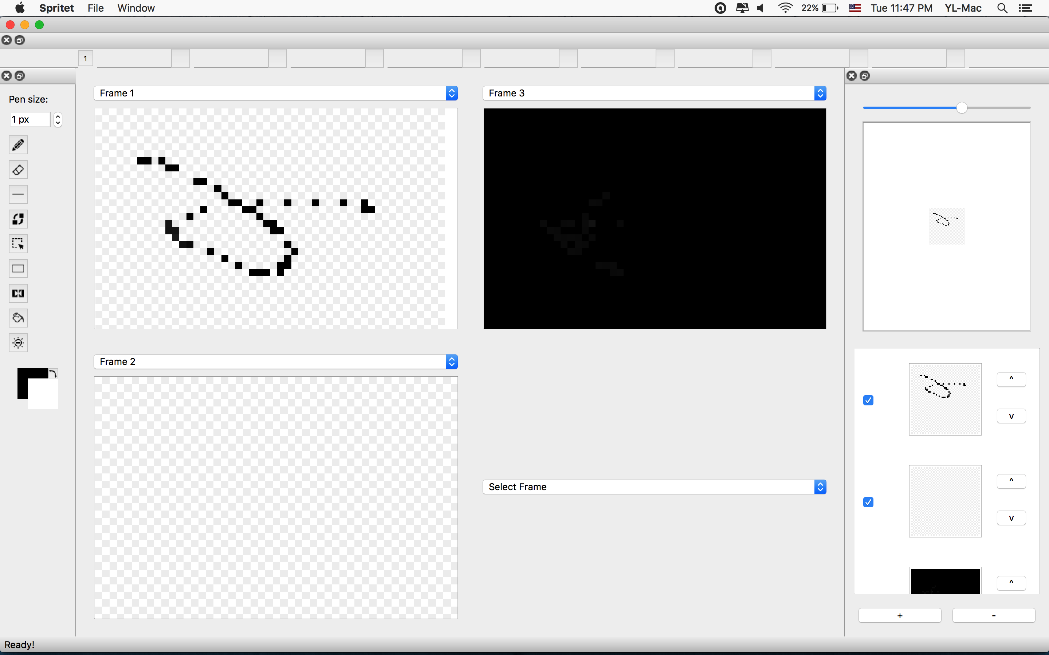
2. Click and hold and drag the mouse: 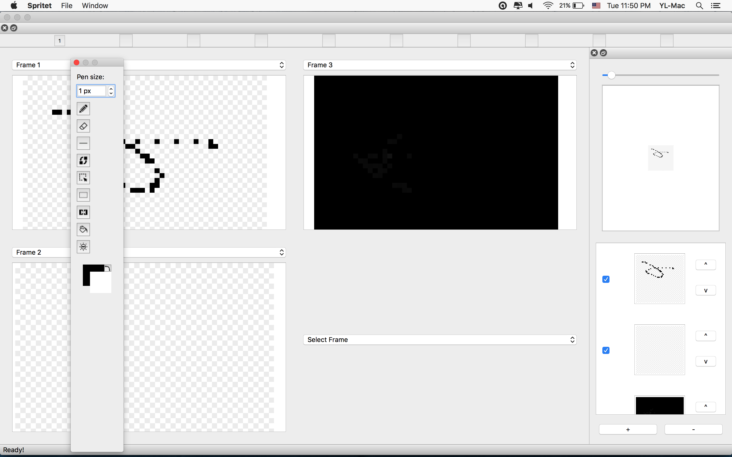
3. Release the mouse to finish the reposition. Either free floating or in a dockable position, which can be either where the frame started or the opposite side:
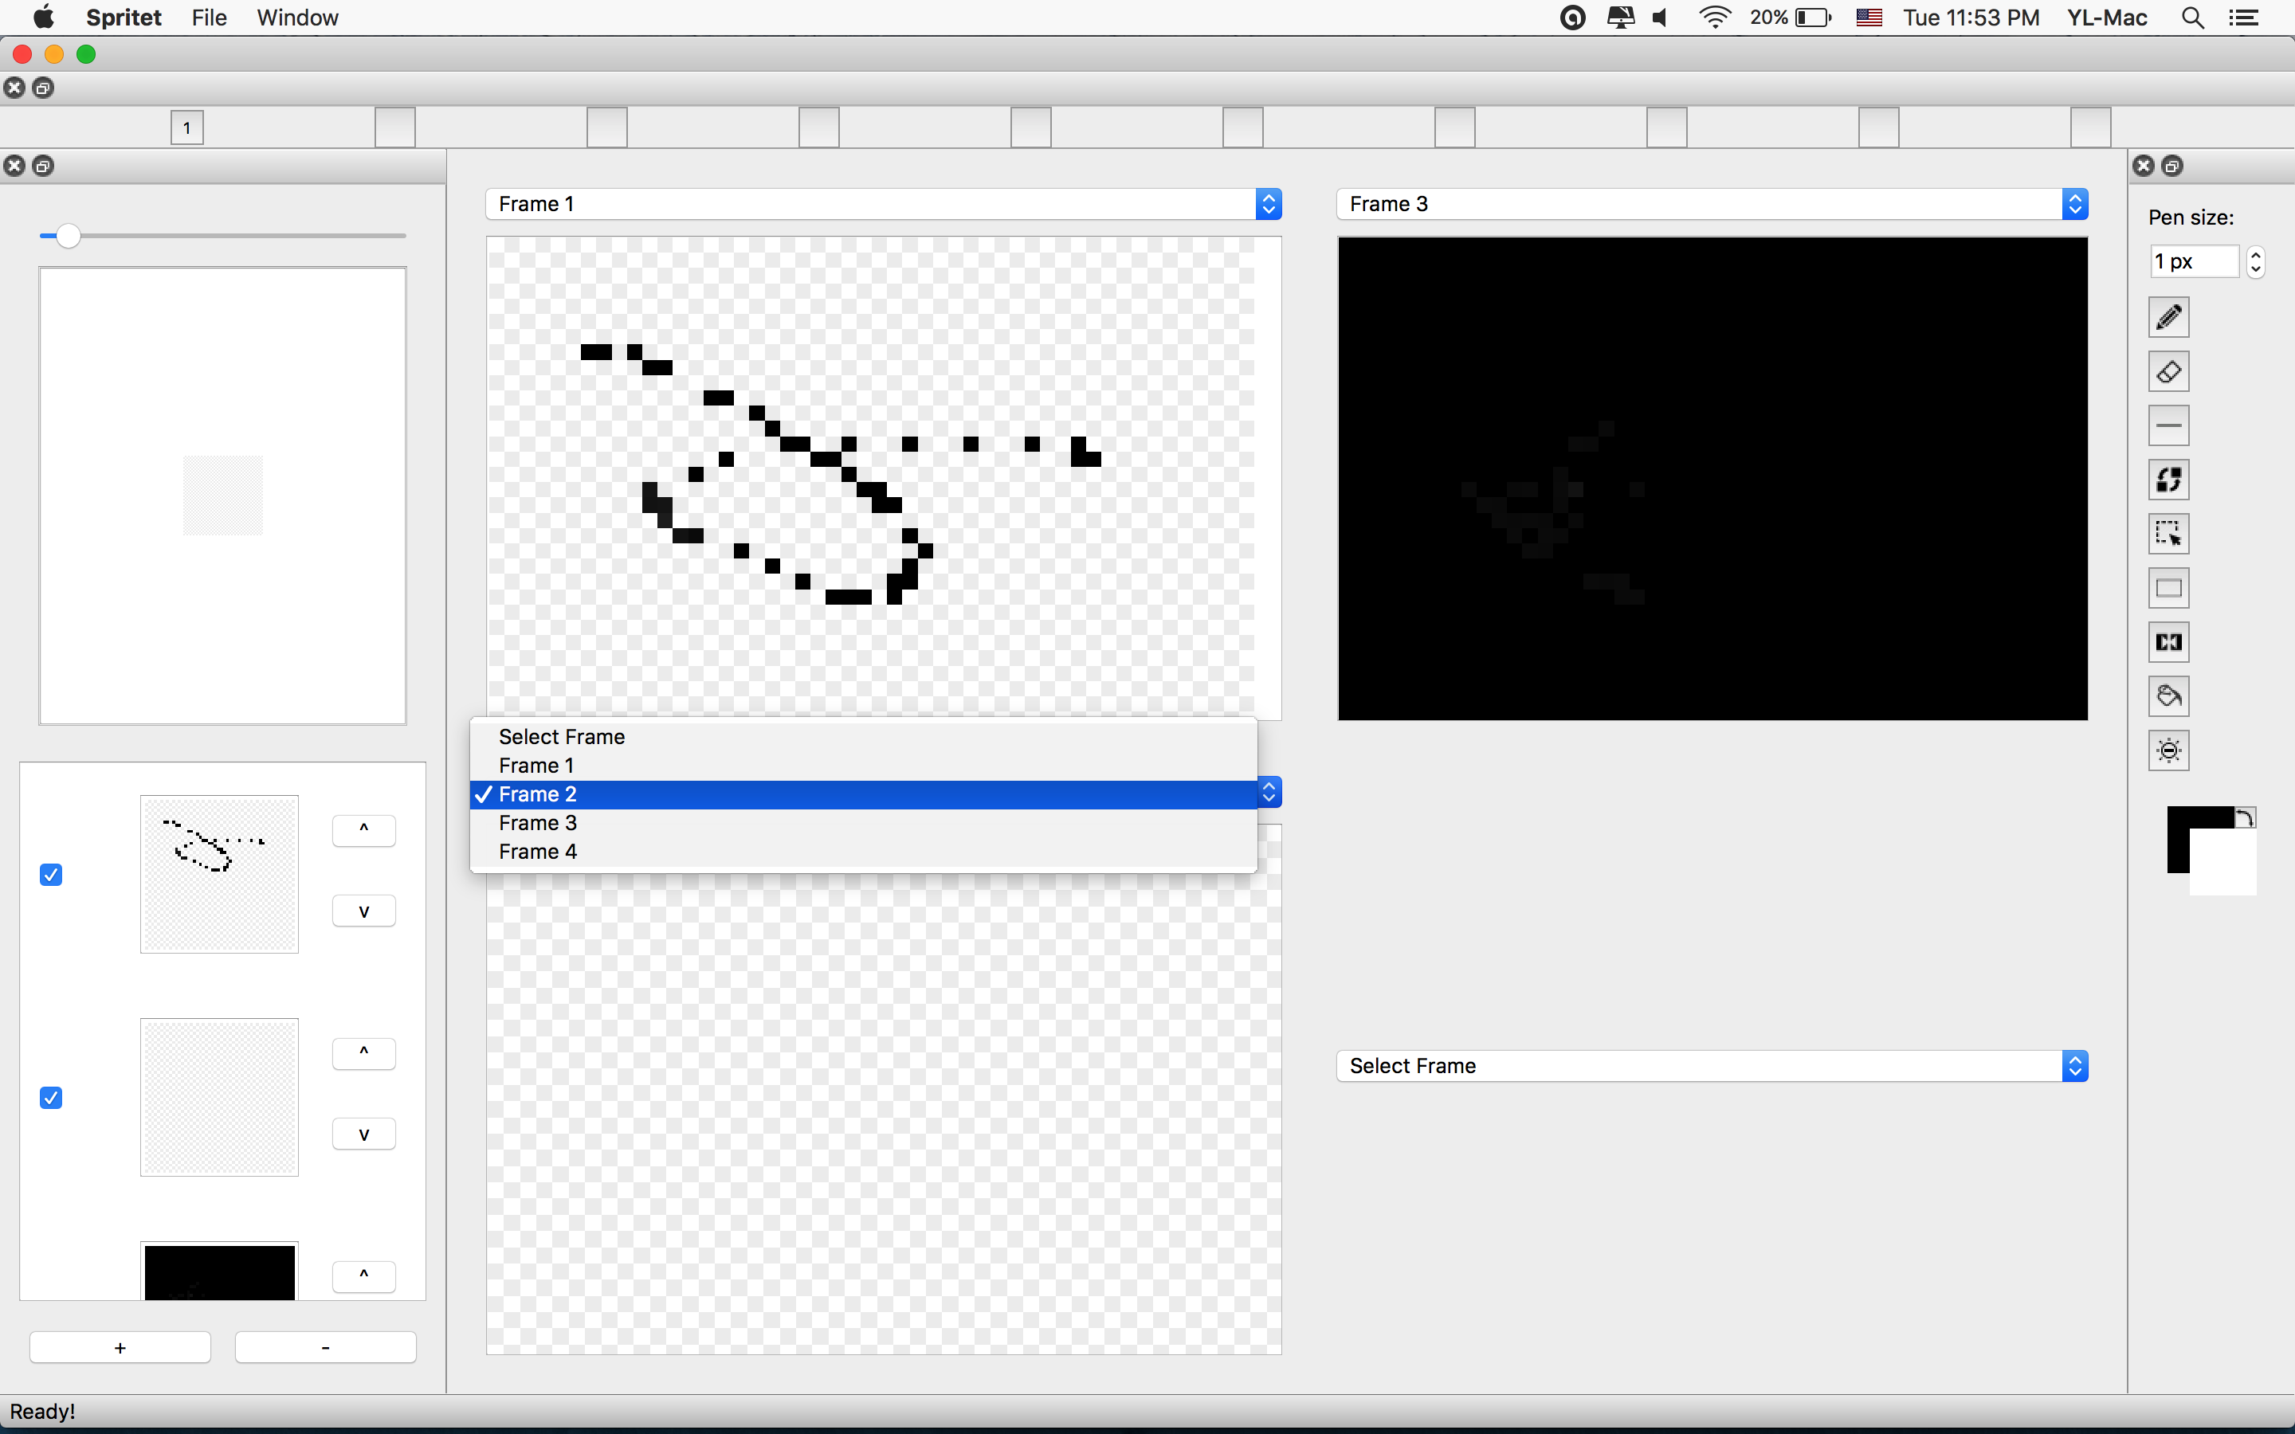
Saving
After making some changes,to save a file simply open the File menu and click Save or Save As. If the file had not been saved before, the user will be directed to the Save As dialog. Subsequent saves will save to the given file.
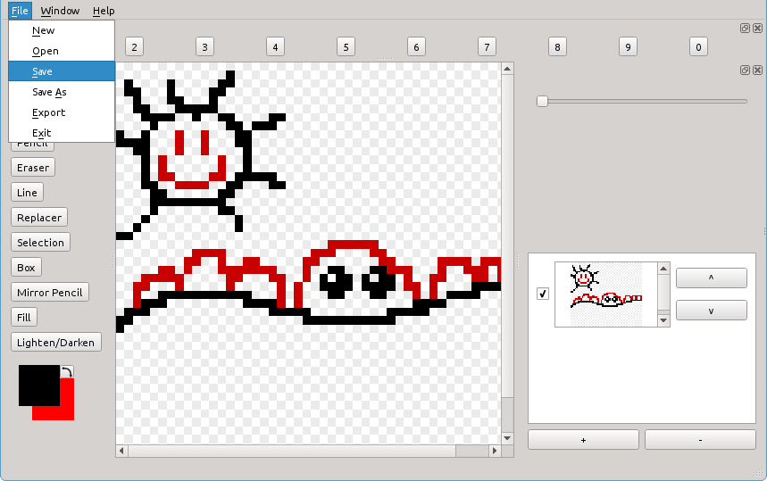

Loading
To load a file, simply open the File menu and click Open
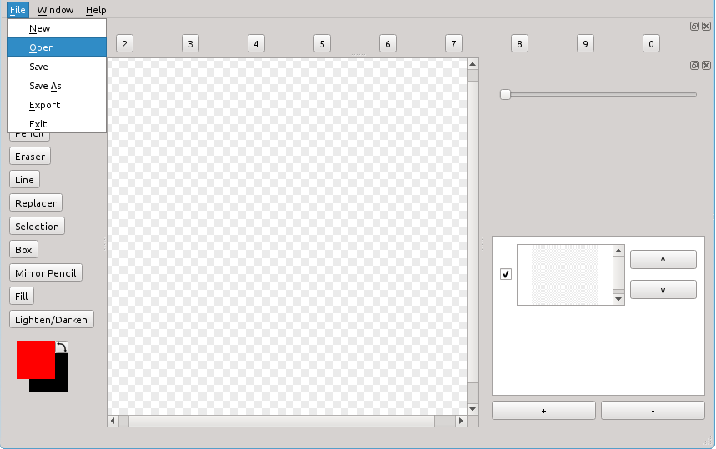
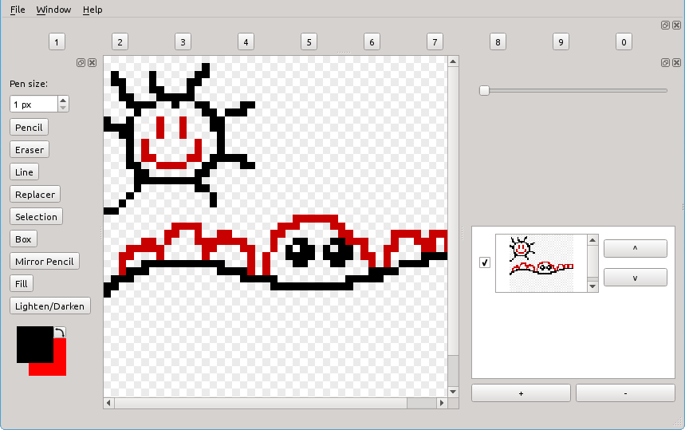

Internationalization Support
Spritet is available to be used in a variety of languages. Currently. Spritet is translated into:
Language | ISO 639-1 code | Example ISO 3166-1 code
Chinese | zh | CN
English (default) | en | US
French | fr | FR
German | de | DE
Spanish | es | ES
To change which language is in use, either set the system language through the normal interface or, on MacOS and Linux systems, using the terminal run, using German as an example:
$ export LANG=”de_DE”
$ Spritet
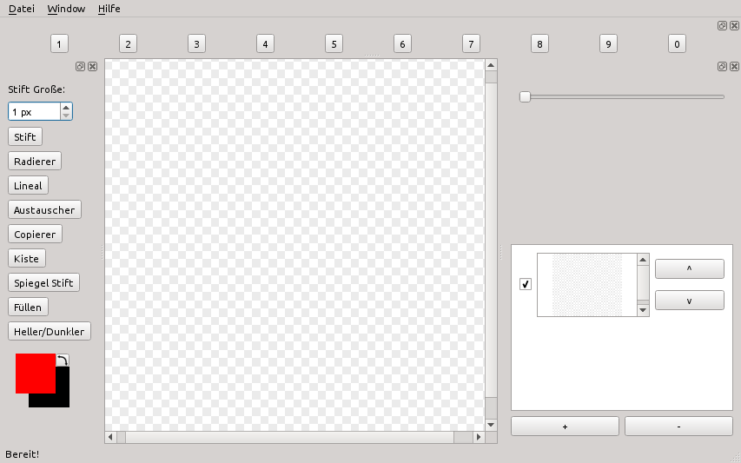
Replace de_DE with the ISO 639-1 language code and ISO 3166-1 region code to specify the language to use

